# Johnson DAD 220 Database Documentation Template

Complete these steps as you work through the directions for Project One. Replace the bracketed text with your screenshots and brief explanations of the work they capture. Each screenshot and its explanation should be sized to approximately one quarter of the page, with the description written below the screenshot. Follow these rules for each of the prompts and questions below. Review the example document located in the Project One Supporting Materials for assistance.

## Step One: Create a Database

1. Navigate to your online integrated development environment (IDE). List and record the SQL commands that you used to complete this step here:



To begin using the IDE, **mysql** was entered before beginning to update my database.

1. Create a database schema called QuantigrationUpdates. List out the database name. Provide the SQL commands you ran against MySQL to successfully complete this in your answer:

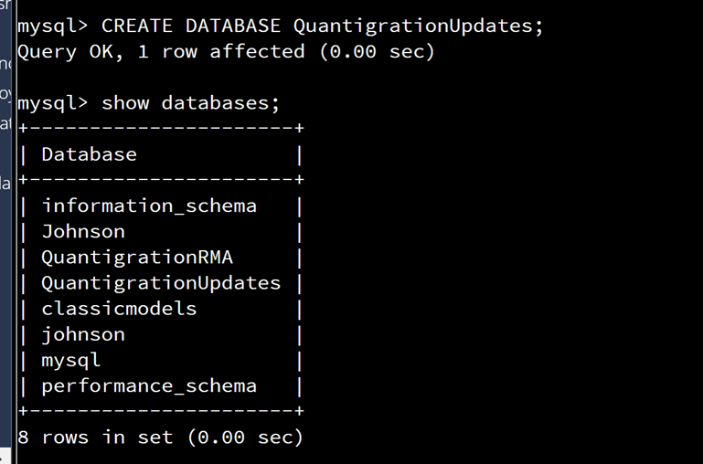

To create the QuantigrationUpdates database and displays my current databases, I used the following commands:

**CREATE DATABASE QuantigrationUpdates;** + **show databases;**

1. Using the entity relationship diagram (ERD) as a reference, create the following tables with the appropriate attributes and keys:
   1. A table named **Customers** in the QuantigrationUpdates database, as defined on the project ERD. Provide the SQL commands you ran against MySQL to complete this successfully in your answer:

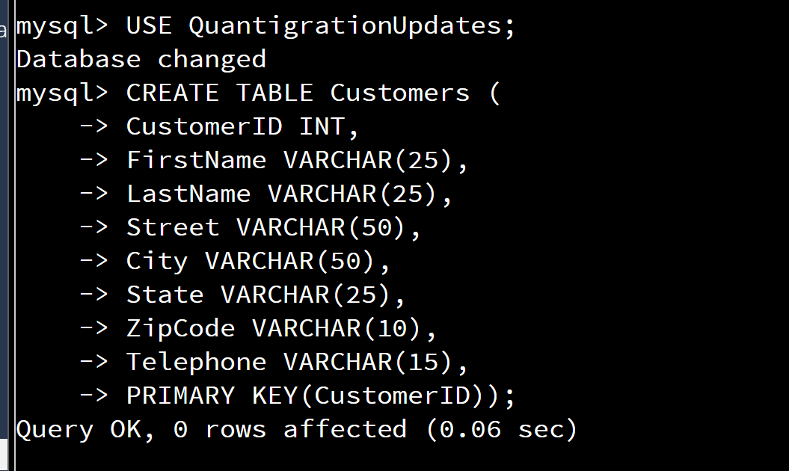

The following command was used to create the Customers table of the updated Quantigration database: **CREATE TABLE Customers (**

**CustomerID INT,**

**FirstName VARCHAR(25),**

**LastName VARCHAR(25),**

**Street VARCHAR(50),**

**City VARCHAR(50),**

**State VARCHAR(25),**

**ZipCode VARCHAR(10),**

**Telephone VARCHAR(15),**

**PRIMARY KEY(CustomerID));,**

* 1. A table named **Orders** in the QuantigrationUpdates database, as defined on the project ERD. Provide the SQL commands you ran against MySQL to complete this successfully in your answer:

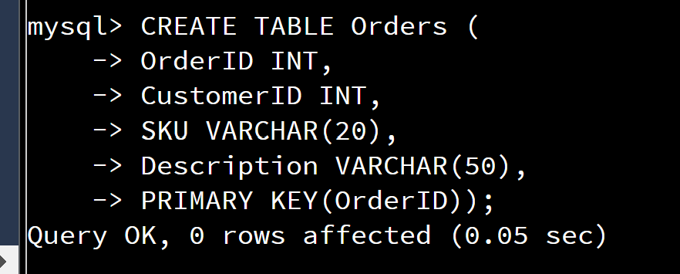

The following command was used to create the Orders table of the updated Quantigration database:

**CREATE TABLE Orders (**

**OrderID INT,**

**CustomerID INT,**

**SKU VARCHAR(20),**

**Description VARCHAR(50),**

**PRIMARY KEY(OrderID));**

* 1. A table named **RMA** in the QuantigrationUpdates database, as defined on the project ERD. Provide the SQL commands you ran against MySQL to complete this successfully in your answer:

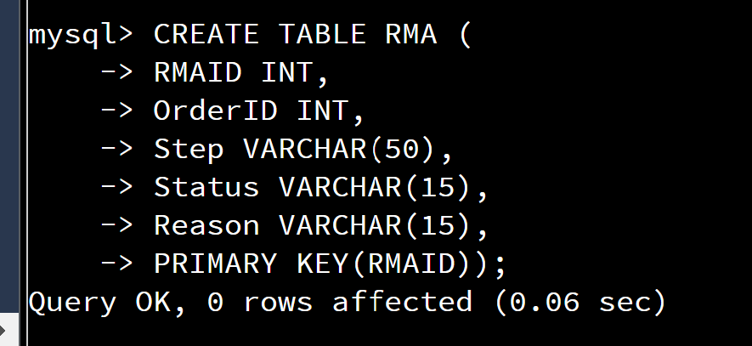

The following command was used to create the Orders table of the QuantigrationUpdates database:

**CREATE TABLE RMA (**

**RMAID INT,**

**OrderID INT,**

**Step VARCHAR(50),**

**Status VARCHAR(15),**

**Reason VARCHAR(15),**

**PRIMARY KEY(RMAID));**

## Step Two: Load and Query the Data

1. **Import the data from each file into tables.** 
   * Use the QuantigrationUpdates database, the three tables you created, and the three CSV files preloaded into Codio.
   * Use the import utility of your database program to load the data from each file into the table of the same name. You will perform this step three times, once for each table.
2. **Write basic queries against imported tables to organize and analyze targeted data.** For each query, replace the bracketed text with a screenshot of the query and its output. You should also include a 1- to 3-sentence description of the output.
   * Write an SQL query that returns the **count** of orders for customers located only in the city of Framingham, Massachusetts.
     1. How many records were returned?

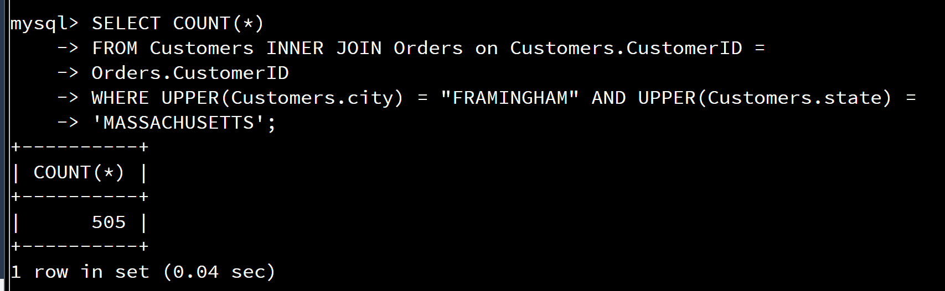

After using the following command, I was able to determine 505 as the number of orders for customers in Massachusetts, which was entered after loading Customers, Orders, and RMA data:

**SELECT COUNT(*)**

**FROM Customers INNER JOIN Orders on Customers.CustomerID =**

**Orders.CustomerID**

**WHERE UPPER(Customers.city) = "FRAMINGHAM" AND UPPER(Customers.state) =**

**'MASSACHUSETTS';**

* + Write an SQL query to **select all** of the Customers located in the state of Massachusetts.
    1. Use a WHERE clause to limit the number of records in the Customers table to only those who are located in Massachusetts.
    2. Record an answer to the following question: How many records were returned?

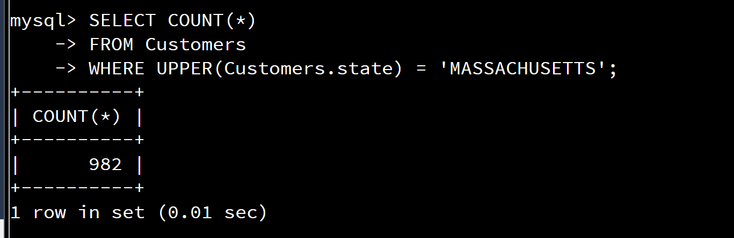

The following command was entered to determine the number of records, which were 982 customers located in Massachusetts:

**SELECT COUNT(*)**

**FROM Customers**

**WHERE UPPER(Customers.state) = 'MASSACHUSETTS';**

* + Write a SQL query to insert four new records into the Orders and Customers tables using the following data:

**Customers Table**

| **CustomerID** | **FirstName** | **LastName** | **StreetAddress** | **City** | **State** | **ZipCode** | **Telephone** |
| --- | --- | --- | --- | --- | --- | --- | --- |
| 100004 | Luke | Skywalker | 15 Maiden Lane | New York | NY | 10222 | 212-555-1234 |
| 100005 | Winston | Smith | 123 Sycamore Street | Greensboro | NC | 27401 | 919-555-6623 |
| 100006 | MaryAnne | Jenkins | 1 Coconut Way | Jupiter | FL | 33458 | 321-555-8907 |
| 100007 | Janet | Williams | 55 Redondo Beach Blvd | Torrence | CA | 90501 | 310-555-5678 |

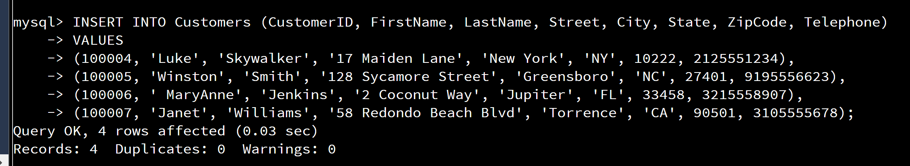

The following command was entered to reflect the customers and customer information as seen in the table above this screenshot:

**INSERT INTO Customers (CustomerID, FirstName, LastName, Street, City, State, ZipCode, Telephone)**

**VALUES**

**(100004, 'Luke', 'Skywalker', '17 Maiden Lane', 'New York', 'NY', 10222, 2125551234),**

**(100005, 'Winston', 'Smith', '128 Sycamore Street', 'Greensboro', 'NC', 27401, 9195556623),**

**(100006, ' MaryAnne', 'Jenkins', '2 Coconut Way', 'Jupiter', 'FL', 33458, 3215558907),**

**(100007, 'Janet', 'Williams', '58 Redondo Beach Blvd', 'Torrence', 'CA', 90501, 3105555678);**

**Orders Table**

| **OrderID** | **CustomerID** | **SKU** | **Description** |
| --- | --- | --- | --- |
| 1204305 | 100004 | ADV-24-10C | Advanced Switch 10GigE Copper 24 port |
| 1204306 | 100005 | ADV-48-10F | Advanced Switch 10 GigE Copper/Fiber 44 port copper 4 port fiber |
| 1204307 | 100006 | ENT-24-10F | Enterprise Switch 10GigE SFP+ 24 Port |
| 1204308 | 100007 | ENT-48-10F | Enterprise Switch 10GigE SFP+ 48 port |

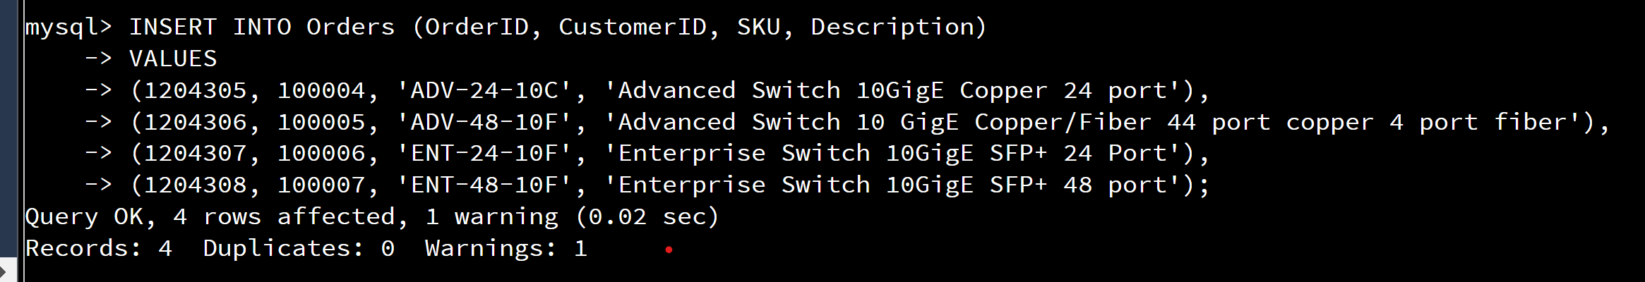

The following command shows the orders that are shown above this screenshot:

**INSERT INTO Orders (OrderID, CustomerID, SKU, Description)**

**VALUES**

**(1204305, 100004, 'ADV-24-10C', 'Advanced Switch 10GigE Copper 24 port'),**

**(1204306, 100005, 'ADV-48-10F', 'Advanced Switch 10 GigE Copper/Fiber 44 port copper 4 port fiber'),**

**(1204307, 100006, 'ENT-24-10F', 'Enterprise Switch 10GigE SFP+ 24 Port'),**

**(1204308, 100007, 'ENT-48-10F', 'Enterprise Switch 10GigE SFP+ 48 port');**

* + In the Customers table, perform a query to count all records where the city is Woonsocket, Rhode Island.
    1. How many records are in the Customers table where the field “city” equals “Woonsocket”?

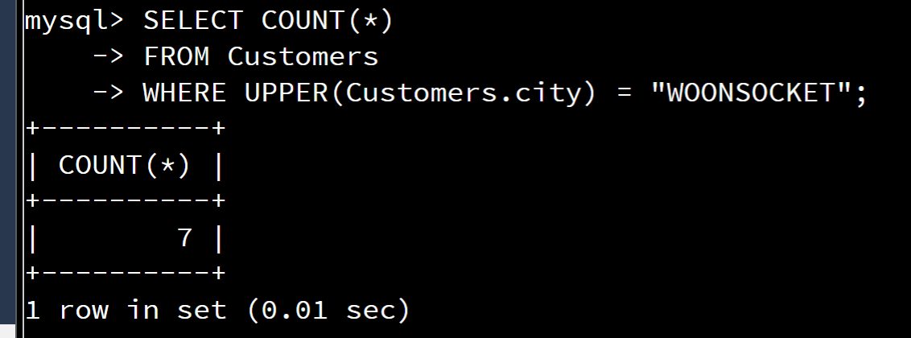

This command helped me determine how many customers are in Woonsocket, Rhode Island:

**SELECT COUNT(*)**

**FROM Customers**

**WHERE UPPER(Customers.city) = "WOONSOCKET";**

* + In the RMA database, update a customer’s records.
    1. Write an SQL statement to select the current fields of **status** and **step** for the record in the **RMA** table with an **orderid** value of “5175.”
       1. What are the current status and step?

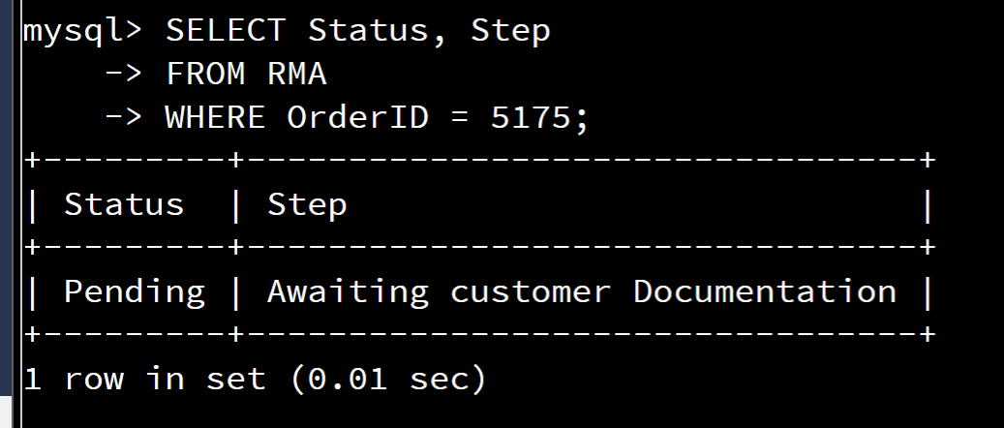

This command helped me update a customer’s record which displays the status and step of their order:

**SELECT Status, Step**

**FROM RMA**

**WHERE OrderID = 5175;**

* + 1. Write an SQL statement to update the **status** and **step** for the **OrderID**, 5175 to **status** = “Complete” and **step** = “Credit Customer Account.”
       1. What are the updated **status** and **step** values for this record?

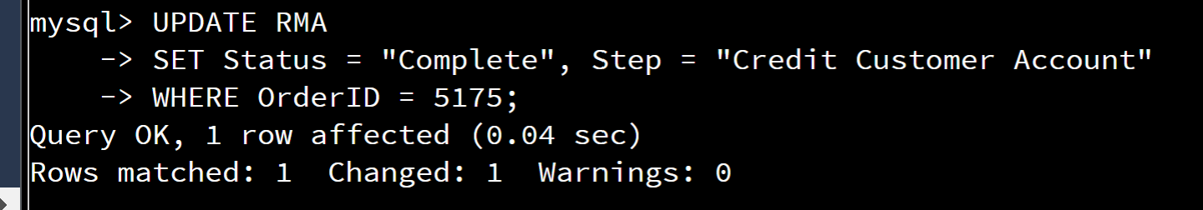

The following command updated the customer status by changing from pending to complete with the step of “Credit Customer Account”:

**UPDATE RMA**

**SET Status = "Complete", Step = "Credit Customer Account"**

**WHERE OrderID = 5175;**

* + Delete RMA records.
    1. Write an SQL statement to delete all records with a reason of “Rejected.”
       1. How many records were deleted?

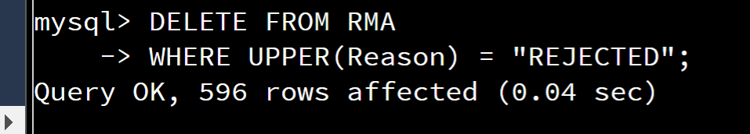

The following command deleted 596 records as “REJECTED”:

**DELETE FROM RMA**

**WHERE UPPER(Reason) = "REJECTED";**

1. **Update your existing tables** from “Customer” to “Collaborator” using SQL based on this change in requirements. Provide the SQL commands you ran against MySQL to complete this successfully in your answer:
   1. Rename all instances of “Customer” to “Collaborator.”

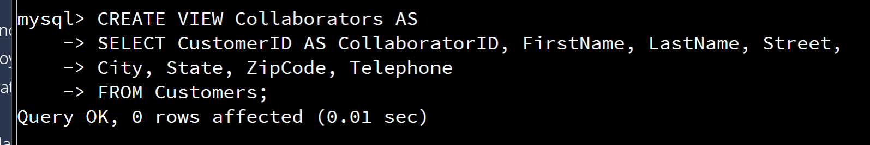

This command changed the name “Customer” to “Collaborator”, which displays the effects after using the command (show tables;) as well:

**CREATE VIEW Collaborators AS**

**SELECT CustomerID AS CollaboratorID, FirstName, LastName, Street,**

**City, State, ZipCode, Telephone**

**FROM Customers;**

1. **Create an output file of the required query results.** Write an SQL statement to list the contents of the **Orders** table and send the output to a file that has a .csv extension.

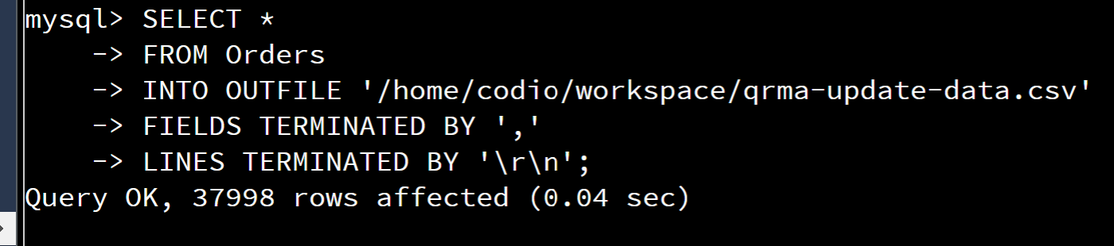

Finally, with this command, I was able to complete the QuantigrationUpdates database by using my updated file:

**SELECT \***

**FROM Orders**

**INTO OUTFILE '/home/codio/workspace/qrma-update-data.csv'**

**FIELDS TERMINATED BY ','**

**LINES TERMINATED BY '\r\n';**